THE EARTH

Structure

Crust - thin layer of hardened, relatively light rock; from 5 - 40 km thick
(30 km average).

Mantle - semi-solid (plastic) magma; very hot due to the pressure of the
overlying rock.

Outer core - molten or liquid; around 5 000 °C.

Inner core - solid; around 5 000 °C.

Crust

The crust "floats" on the semi-liquid magma.

i.e. The continental plates float and are able to move.

As the magma moves, the plates move.

• Where plates collide, mountains can form.

e.g. Himalayas

• Where one plate slides under another, mountains and volcanoes can form.

e.g. West coast of USA.

Where magma can escape through cracks in the crust, a volcano can form. It builds up its structure over time.

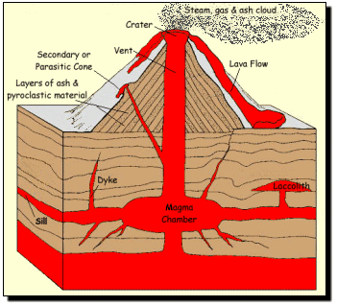

Volcanic rocks - formed at or near the surface as lava cools. Produces small
crystals as it cools quickly.

e.g. basalt rock

Plutonic rocks - form deep underground. Produces large crystals as it cools
slowly.

e.g. granite rock

Weathering

There are two forms of weathering.

1. Physical

Changes in temperature will cause rocks to crack and split.

e.g. Quick change of temperature from night to day.

When ice forms in cracks, it expands and splits the rock.
Plants such as trees and shrubs can crack rocks with their roots as they grow.

2. Chemical

Minerals in rocks can react with chemicals in the air.

e.g. CO₂ dissolves in rain to form a weak carbonic acid (H₂CO₃) solution. this
reacts with minerals and weakens the rock.

O₂ in air can react with Fe in minerals to form rust - a lot of rocks are
coloured brown.

Erosion

This is the movement of soil around by wind and water. Ice in a glacier can also move rocks and boulders.

Moving water is the most efficient erosion mechanism.

e.g. The Colorado River in America is hundreds of metres below the surface of
the surrounding land. It has taken millions of years to carve out the Grand
Canyon.

Where humankind has cleared land for farming, wind erosion is a major problem.

e.g. In the wheat belt of WA, dust storms are quite common in summer once the
wheat has been harvested. There is nothing to prevent the soil from
moving.

Glaciers move very slowly - only a few metres per year - but they grind boulders over bedrock.

e.g. The Fox Glacier in New Zealand.

